**Excretory System – Notes**

* Excretion: The process of removing **metabolic** wastes before they become toxic.
* Elimination: The process of removing **non-metabolic** wastes.

|  |  |
| --- | --- |
| **Excretory organ**: | **Waste excreted**: |
| Skin | Water, urea and lactic acid. |
| Lungs | Carbon dioxide and water. |
| Kidneys | Water, urea, uric acid and creatinine. |
| Liver | No waste is directly excreted from the liver, but the liver breaks down amino acids into ammonia which gets converted to urea, and then eliminated from the body in urine – this is called deamination. |
| Alimentary canal (large intestine) | Bile pigments. |

Liver:

* Some protein is broken down in the body all the time, although most of the breakdown is incomplete.
* A very small amount of amino acid and protein is lost from the body via urine, skin, hair and fingernails.
* If other energy sources have been used up, the body is able to metabolise large amounts of proteins.
* This process is called deamination.
* The remaining part of the amino acid (once the amino group (NH2) has been removed) is converted into a carbohydrate which can be readily broken down by cells to release energy, carbon dioxide and water.



* The liver rapidly converts ammonia to the less toxic molecule urea.



Skin:

* Dissolved in sweat are sodium chloride, lactic acid and urea.
* Some drugs are also excreted by the skin.
* Sweat glands are located in the lower layers of the skin.
* A duct carries the sweat to a hair follicle or to the skin surface where it opens at a pore.
* Cells surrounding the glands are able to contract and squeeze the sweat to the surface.

Kidneys:

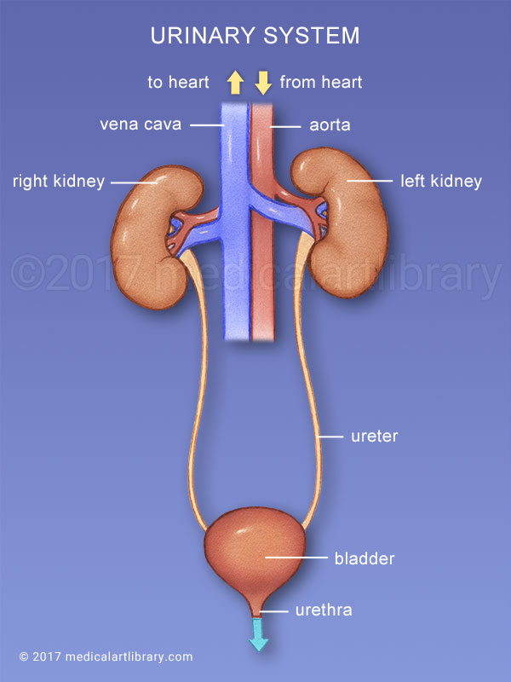

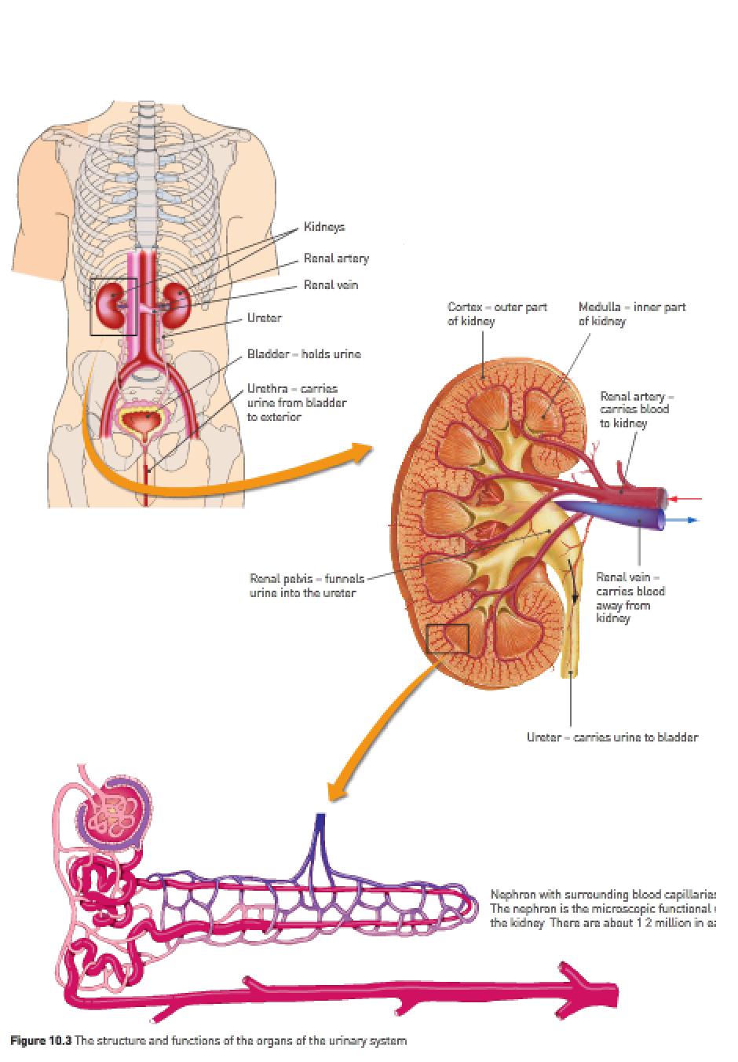

**Nephron structure**:

1. Renal artery.
2. Afferent arteriole.
3. Glomerular capsule (Bowman’s capsule).
4. Glomerulus.
5. Efferent arteriole.
6. Proximal convoluted tubule.
7. Loop of Henle.
8. Distal convoluted tubule.
9. Collecting duct.
10. Renal pelvis.
11. Ureter.

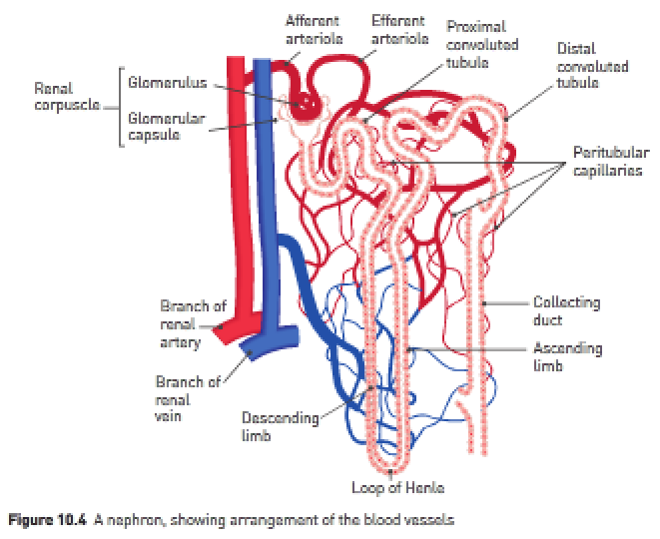

Filtration – Small molecules e.g., glucose, amino acids, water, urea and uric acid move **from the blood plasma in the glomerulus into the Bowman’s capsule** (aka Glomerular Capsule).

Note: This process is assisted by:

* Renal artery and afferent arteriole coming from the aorta.
* Large diameter of afferent arteriole and small diameter of efferent arteriole.
* Thin single-cell layer of the glomerulus capillaries.
* Small pores (holes) in the Bowman’s Capsule.

Large molecules e.g., proteins and erythrocytes can’t undergo filtration.

Selective reabsorption – Molecules that are useful (**required by the body**) are **reabsorbed from the filtrate in the proximal convoluted tubule back into the blood plasma** within the **surrounding peritubular capillaries**. The filtrate is anything found in the renal tubules (consists of water, salts, amino acids, fatty acids, glucose, urea, uric acid, creatinine hormones, toxins and various ions).

Obligatory reabsorption of water – **90% of the water** that undergoes filtration is **reabsorbed from the filtrate in the proximal convoluted tubule to the blood plasma** in the **surrounding peritubular capillaries**.

Tubular secretion – Large waste molecules e.g., creatinine, drugs and some small waste molecules e.g., urea and H+ and K+ ions move via **active transport from blood plasma in the peritubular capillaries into the filtrate in the Loop of Henle**.

Note: The secretion of H+ ions into the filtrate enables blood plasma to maintain a pH of around 7.4 (slightly alkaline). Urine is acidic (pH: 6).

Tubular secretion can be either active or passive and has 2 main effects:

1. Removes certain unwanted materials from the body.
2. Controls the pH of the blood by secreting H+ and NH4+ ions into the filtrate.

Water and other substances not reabsorbed drain from the collecting ducts into the renal pelvis. The urine then drains into the ureters and is pushed by waves of muscular contraction to the urinary bladder where it’s stored. The bladder is a hollow muscular organ from which the urethra exits. The urethra carries urine from the bladder to the exterior.

Facultative reabsorption of water – If the body is low on fluid (blood plasma) e.g., in situation with lots of sweating, salty meals, etc. the body can **actively cause water reabsorption** under the action of a hormone called **Antidiuretic hormone**. Water moves **from the filtrate in the distal convoluted tubule into the plasma** in the **peritubular capillaries**.

Depending on the body’s water requirements, the permeability of the plasma membranes of cells making up parts of the tubules can be changed. Thus, more or less water can be reabsorbed depending on the body’s requirements. This is an active process.

Reabsorption:

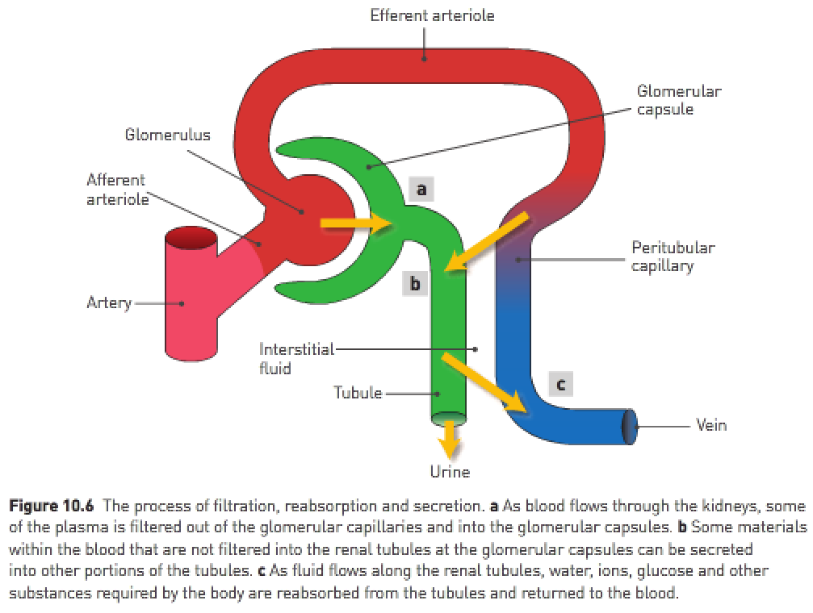

Some ways in which the structure of the kidney is related to its function of excretion of waste and regulation of water content of the body:

* The glomerular capsule **surrounds** the glomerulus to **collect the fluid filtered out of the blood capillaries**.
* The arteriole leading out of the glomerulus has a **smaller diameter** than the arteriole leading in. This **raises the blood pressure** so that **more fluid is filtered out of the blood**.
* The tubule has **2 sets of convolutions** and a **long loop** so that each tubule has a **large surface area** for reabsorption and secretion.
* Each kidney has **over a million nephrons** so that the total surface area available for reabsorption and secretion is **extremely large**.

|  |  |
| --- | --- |
| **Region of nephron**: | **Activities taking place**: |
| Renal corpuscle | Filtration of blood from capillaries of glomerulus.  Formation of filtrate in the glomerular capsule. |
| Proximal convoluted tubule and Loop of Henle | Reabsorption of sodium, potassium, chlorine and bicarbonate ions.  Reabsorption of glucose.  Passive reabsorption of water by diffusion. |
| Distal convoluted tubule | Reabsorption of sodium ions.  Active reabsorption of water depending on the body’s water needs.  Secretion of hydrogen and potassium ions, creatinine and certain drugs e.g., penicillin. |
| Collecting duct | Active reabsorption of water depending on the body’s water needs. |

**Marking key**:

|  |  |
| --- | --- |
| **Structure**: | **Function**: |
| Glomerulus | Allows some fluid and dissolved substances to be filtered from the blood retaining the formed elements in the bloodstream. |
| Afferent arteriole | Transports blood containing urea and all other nutrients into the glomerulus from an arteriole that branches off the renal artery. |
| Efferent arteriole | Transports blood from the glomerulus to the convoluted tubule and descending limb of the Loop of Henle for the reabsorption of vital components of the filtrate. |
| Distal convoluted tubule | Adds drugs, creatinine, hydrogen and potassium ions to the filtrate, or carries the filtrate to the collecting tubule. |
| Collecting duct | Transports the filtrate, now urine, to the tip of the renal pyramids. |
| Loop of Henle | Concentrates the filtrate or carries the filtrate to the distal convoluted tubule. |

**Urine composition**:

* The body must excrete its waste products e.g., urea, sulfates and phosphates in solution and so elimination of these wastes **requires a certain amount of water loss**.
* Regardless of the amount of water available in the body or the amount taken in, about half a liter of water must be lost each day simply to remove wastes.
* When **water content of body fluids is low**, the **urine that’s secreted is very concentrated**.

|  |  |  |  |
| --- | --- | --- | --- |
| **Chemical component**: | **Filtrate**: | **Reabsorbed substances**: | **Urine**: |
| Water | 180L | 178–9L | 1–2L |
| Sodium, chloride and other ions | 1500g | 1485g | 15g |
| Proteins | 2g | 1.9g | 0.1g |
| Glucose | 180g | 180g | 0g |
| Urea | 53g | 28g | 25g |
| Uric acid | 8.5g | 7.5g | 1g |
| Creatinine | 1.6g | 0g | 1.6g |

**Under normal circumstances**:

* Around **99% of the water that enters the nephrons is reabsorbed**.
* The urine **doesn’t usually contain significant amounts of protein**.
* The urine **doesn’t usually contain any glucose**.
* The main materials making up urine (besides water) are **urea, ions, uric acids and creatinine** (**I** **C** **U**r **U**niqueness).
* Uric acid is produced by the **metabolism of substances called purines**. Purines may come from the breakdown of nucleic acids when cells die, and they also occur naturally in many foods.
* Creatinine is produced in muscle from the **breakdown of creatinine phosphate**, an energy-rich molecule.

|  |  |
| --- | --- |
| **Component**: | **%** |
| Water | 96 |
| Urea | 2 |
| Various ions | 1.5 |
| Other | 0.5 |

**Kidney stones**:

* Kidney stones are formed from **solid crystals** that build up inside the kidneys.
* Kidney stones usually **form when urine becomes too concentrated**.
* If the kidneys are **small enough**, they may pass **down the ureter** and **out of the body** **through the urethra** without being noticed.
* Crystals may **combine to form stones**. Large stones may get stuck in the ureter, bladder or urethra, causing intense pain.

**Kidney failure**:

* Most kidney diseases affect the **glomeruli**, reducing their **ability to filter the blood**.
* Proteins and sometimes erythrocytes may **leave the blood of the glomerulus** and will then be **present in the urine**.
* If **excessive proteins are lost** in the urine, **blood protein levels fall** and **fluid accumulates in the tissues**, causing **swelling** in the hands, feet, face or other areas.
* Kidney failure: When the kidneys lose their ability to **excrete waste** and **control the level of fluid** in the body.
* Kidney failure may occur suddenly but is more likely to develop over a period of years.
* Factors e.g., diabetes, high blood pressure and kidney diseases slowly destroy the nephrons in the kidneys.
* Eventually, the only way to maintain life is by dialysis or a kidney transplant.

**Dialysis**:

* Dialysis: A **method of removing wastes** from the blood when kidney failure occurs.
* There are 2 types of dialysis: **peritoneal** dialysis and **haemodialysis**.

**Peritoneal dialysis**:

* Peritoneum: A membrane that **lines the inside of the abdominal cavity** and **covers abdominal organs** e.g., the liver stomach and intestines.
* Peritoneal dialysis occurs inside the body using the peritoneum as a membrane across which waste can be removed.
* For an adult, 2-3L of **fluid are passed through the catheter into the abdominal cavity** – the fluid contains glucose and other substances at concentrations similar to those found in the blood, but no wastes.
* Because of the concentration difference, **wastes will diffuse out of the blood into the fluid** in the abdominal cavity – **useful substances stay in the blood** because there’s **no concentration difference** between the blood and the fluid.
* After a time, the fluid that was placed in the abdominal cavity is drained out through the catheter, along with any wastes and extra water that have diffused from the blood.
* Peritoneal dialysis is usually done each day.

**Haemodialysis**:

* Haemodialysis involves passing the blood through an **artificial kidney or dialysis machine**.
* The blood passes through thousands of fine tubes made of a **differentially permeable membrane** and **immersed in a bath of fluid** – the concentration of substances in the fluid are similar to those in the blood except that the fluid has **no wastes**.
* Because of the concentration differences, **wastes diffuse from the blood into the fluid**.
* Patients spend around 4-5 hours attached to the machine and dialysis is usually done 3 times per week.

Dialysis machine:

